# Access to HE: Computing – Iteration Activities

## Task 1

Write a Python program that prints the numbers 10 to 0 (starting at 10). Then print “Lift-off!”. You will need to import the time module at the start of the program. Include a time delay of 1 second before printing each number, using the statement:

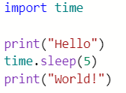

time.sleep(1)

When run, the output will look like:

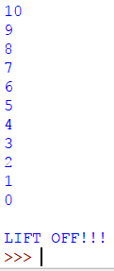

## Task 2

Ask the user to enter 5 numbers. Keep a running total and print the total and average of the numbers. When run, the program will look similar to:

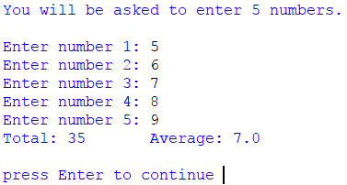

### Note

All code should be fully commented, so you can understand it when you come back to review the code in the future.

## Task 3

Research the **break** control keyword. Write some code that demonstrates it.

## Task 4

Research the **continue** control keyword. Write some code that demonstrates it.

## Task 5

Ask the user for a number, print out the times table for that number.

## Task 6

Print out a calendar.